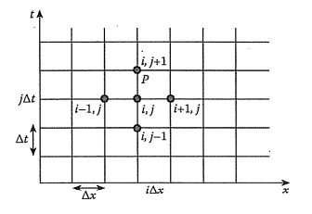

Figure - Finite Difference Scheme

fij

$\frac{∂^{2}V}{∂^{2}x}+\frac{∂^{2}V}{∂^{2}x}=\frac{(Vi+1,j+Vi-1,j+Vi,j+1+Vi,j-1 -4Vi,j)}{(∆x)^2}$

εε

$$∇^{2}V=\frac{∂^{2}V}{∂^{2}x}+\frac{∂^{2}V}{∂^{2}t}=\frac{(Vi+1,j+Vi-1,j-2Vi,j)}{(∆x)^2}+\frac{(Vi,j+1+Vi,j-1-2Vi,j)}{(∆t)^2}$$

$$∇^{2}V=\frac{∂^{2}V}{∂^{2}x}+\frac{∂^{2}V}{∂^{2}x}=\frac{(Vi+1,j+Vi-1,j+Vi,j+1+Vi,j-1 -4Vi,j)}{(∆x)^2}$$

${\left(∆x\right)}^{2}$

(Vi+1,j+Vi-1,j-2Vi,j)/ (∆x)^2

$$\frac{∂^{2}V}{∂^{2}x}+\frac{∂^{2}V}{∂^{2}x}=\frac{(Vi+1,j+Vi-1,j+Vi,j+1+Vi,j-1 -4Vi,j)}{(∆x)^2}=AV=f$$